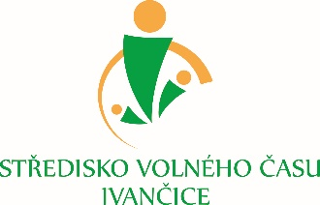


Training course: Communication with no words
Arrival day: Suturday 07.10.2017
Departure day: Sunday 15.10.2017
Activity date: 08.10.-14.10.2017
Place: Ivancice, Czech Republic
Hosting organization: Stredisko volneho casu Ivancice

APPLICATION OF PARTICIPANT

Name:
Surname:
Gender:
Date of birth:
Address:
Country:
Mobile Phone:
Email:
Sending organization:
Special requirement regarding food, dietary need, vegetarian:

Participant with fewer opportunities: Yes No
What type:

1. What kind of youth projects you are working in/worked with?

2. What is your motivation to participate in this training course?

3. Would you like to present anything from your own experience during the training course?

